**Gemini Nutrition App**

Project Members:

Vedant Patil – 22BCE0019

Manan Gupta – 22BCE2220

Shrey Goel – 22BCE3021

Vedang Urade – 22BCE0194

Nutrition App Using Gemini Pro : Your

Comprehensive Guide To Healthy Eating And Well- Being

Nutritionist AI is an innovative mobile application designed to provide personalized dietary recommendations and nutritional advice using the advanced capabilities of the Gemini Pro model. The app leverages artificial intelligence to analyze user data, dietary preferences, and health goals, delivering tailored meal plans, nutritional insights, and wellness tips. The primary aim of Nutritionist AI is to promote healthier eating habits and improve overall well-being through intelligent and data-driven recommendations.

Scenario 1: Weight Loss Journey

Sarah, a 28-year-old with a goal to lose 15 pounds, uses Nutritionist AI to aid her in her weight loss journey. As a vegetarian with a moderate activity level, she inputs her dietary preferences and health goals into the app. Nutritionist AI creates a calorie-controlled, nutrient-dense meal plan tailored to her vegetarian diet. Sarah logs her meals by taking photos or scanning barcodes, and the app provides feedback on her calorie intake and nutritional balance, suggesting necessary adjustments. By syncing her fitness tracker, the app integrates her physical activity data, offering comprehensive insights to help Sarah stay on track with her weight loss while maintaining proper nutrition.

Scenario 2: Managing Diabetes

John, a 45-year-old with Type 2 Diabetes, relies on Nutritionist AI to manage his condition through diet. He inputs his low-carb dietary preference and diabetes condition, and the app generates meal plans that focus on low carbohydrate and high fiber content to help control his blood sugar levels. John uses the app to log his meals, receiving immediate feedback on their suitability for his diabetes management. Detailed nutritional breakdowns highlight carbohydrate content and glycemic index, aiding John in making informed food choices. Additionally, the app provides educational resources about managing diabetes through diet, keeping John well-informed and empowered to handle his condition better.

Scenario 3: Building the Muscle

Emily, a 30-year-old strength training enthusiast, uses Nutritionist AI to support her goal of gaining muscle mass. With a preference for high-protein meals and an intense workout regime, she inputs her dietary preferences and fitness goals into the app. Nutritionist AI generates meal plans rich in protein and essential nutrients necessary for muscle growth. Emily benefits from a variety of high-protein recipes that cater to her needs, with each recipe including detailed instructions and nutritional information. By connecting her fitness tracker, the app accounts for her caloric expenditure and provides insights on balancing her protein intake with her workouts, optimizing her muscle-building efforts.

Technical Architecture

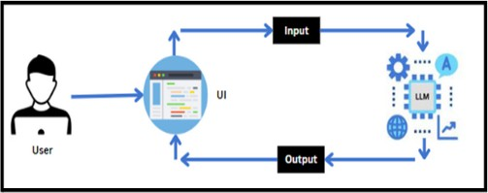

Project Flow

* User interacts with the UI to enter the input.
* User input is collected from the UI and transmitted to the backend using the Google API key.
* The input is then forwarded to the Gemini Pro pre-trained model via an API call.
* The Gemini Pro pre-trained model processes the input and generates the output.
* The results are returned to the frontend for formatting and display.

To accomplish this, we have to complete all the activities listed below:

* Requirements Specification
  + Create a requirements.txt file to list the required libraries.
  + Install the required libraries
* Initialization of Google API Key
  + Generate Google API Key
  + Initialize Google API Key
* Interfacing with Pre-trained Model
  + Load the Gemini Pro pre-trained model
  + Implement a function to get gemini response
  + Implement a function to read PDF content
  + Write a prompt for gemini model
* Model Deployment
  + Integrate with Web Framework
  + Host the Application

Prior Knowledge

You must have the prior knowledge of the following topics to complete this project.

* Generative AI Concepts
* NLP: <https://www.tutorialspoint.com/natural_language_processing/index.htm>
* Generative AI: <https://en.wikipedia.org/wiki/Generative_artificial_intelligence>
* About Gemini: <https://deepmind.google/technologies/gemini/#introduction>
* Gemini API: <https://ai.google.dev/gemini-api/docs/get-started/python>
* GeminiDemo: <https://colab.research.google.com/github/google/generative-ai>[-](https://colab.research.google.com/github/google/generative-ai-docs/blob/main/site/en/gemini-api/docs/get-started/python.ipynb) [docs/blob/main/site/en/gemini-api/docs/get-started/python.ipynb](https://colab.research.google.com/github/google/generative-ai-docs/blob/main/site/en/gemini-api/docs/get-started/python.ipynb)
* Streamlit: <https://www.geeksforgeeks.org/a-beginners-guide-to-streamlit/>

Project Structure

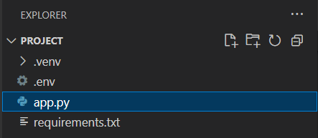

Create the Project folder which contains files as shown below:

* .env file: It securely stores the Google API key.
* Nutrition_app.py: It serves as the primary application file housing both the model and Streamlit UI code.
* requirements.txt: It enumerates the libraries necessary for installation to ensure proper

functioning.

* Additionally, ensure proper file organization and adhere to best practices for version control.

Milestone1 : Requirements Specification

Specifying the required libraries in the requirements.txt file ensures seamless setup and reproducibility of the project environment, making it easier for others to replicate the development environment.

Activity 1 : Create A Requirements.Txt File To List The Required Libraries.

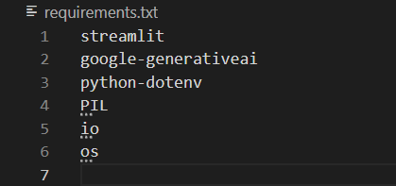

* streamlit: Streamlit is a powerful framework for building interactive web applications with Python.
* streamlit_extras: Additional utilities and enhancements for Streamlit applications.
* google-generativeai: Python client library for accessing the GenerativeAI API, facilitating interactions with pre-trained language models like Gemini Pro.
* python-dotenv: Python-dotenv allows you to manage environment variables stored in a .env file for your Python projects.
* io: It is a Python library for I/0 related functionalities
* os: python library to work os related functionalities incuding the .env path variable

Activity 2 : Install The Required Libraries



* Open the terminal.
* Run the command: pip install -r requirements.txt
* This command installs all the libraries listed in the requirements.txt file

Milestone 2 : Initialization Of Google API Key

The Google API key is a secure access token provided by Google, enabling developers to authenticate and interact with various Google APIs. It acts as a form of identification, allowing users to access specific Google services and resources. This key plays a crucial role in authorizing and securing API requests, ensuring that only authorized users can access and utilize Google's services.

Activity 1 : Generate Google API Key

Click the provided link to access the following webpage.

Link: https://ai.google.dev/gemini-api/docs/api-key

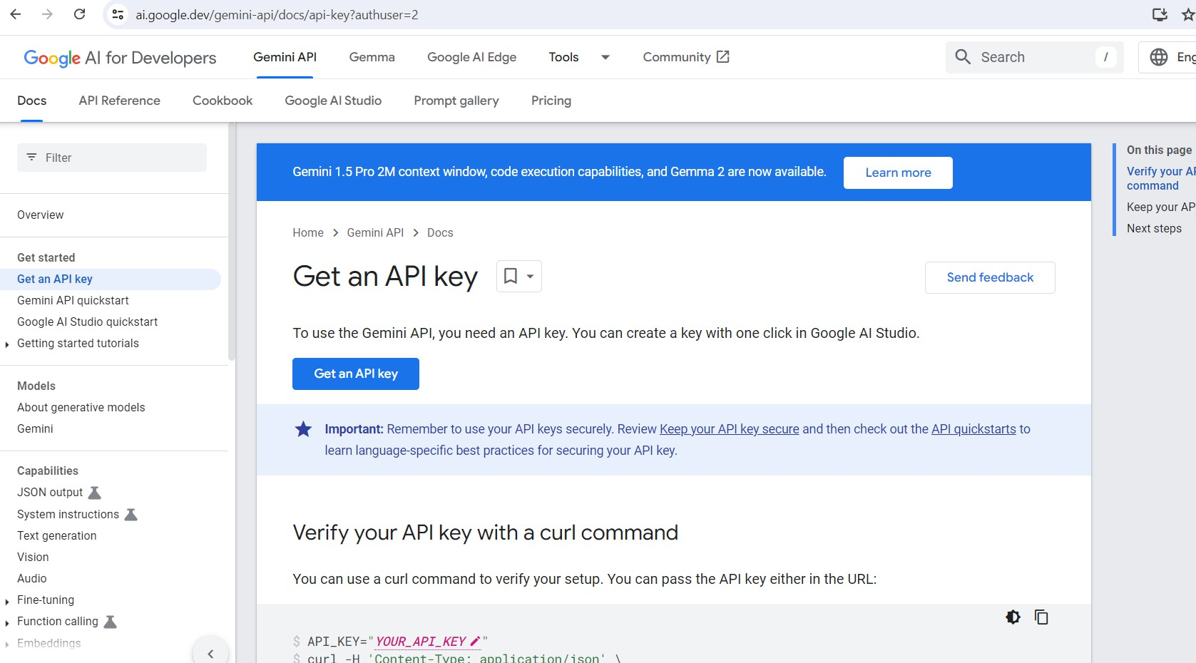

After signing in to your account, navigate to the 'Get an API Key' option. Clicking on this option will redirect you to another webpage as shown below.

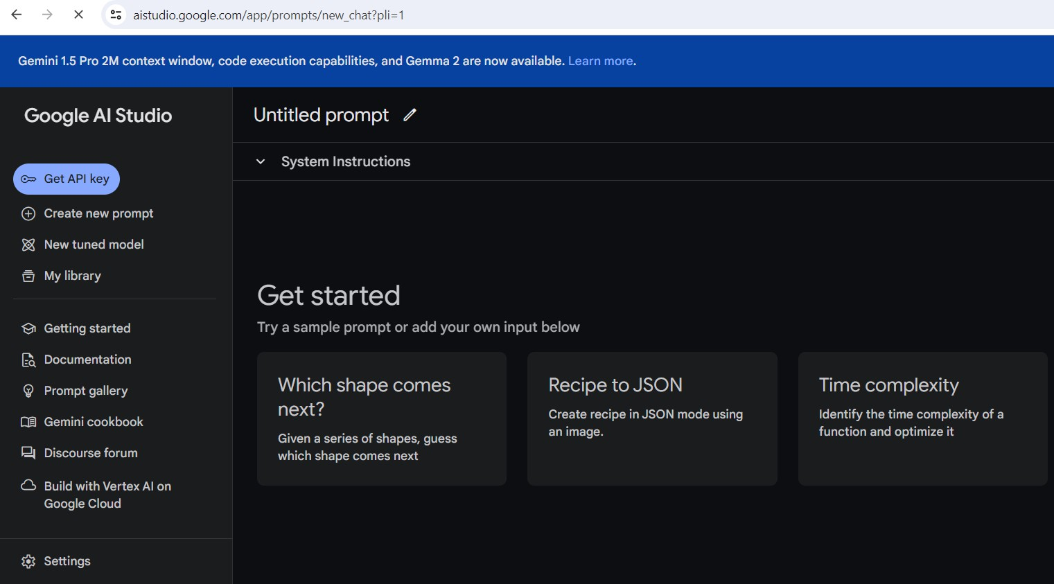

Next, click on 'Create API Key' and choose the generative language client as the project. Then, select 'Create API key in existing project'.

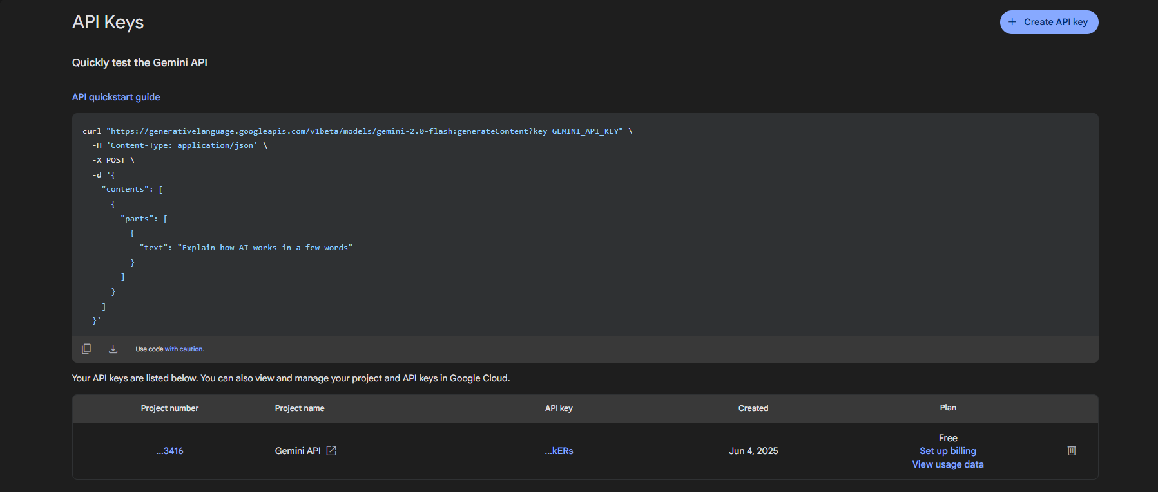

Copy the newly generated API key as it is required for loading the Gemini Pro pre-trained model.

Activity 2 : Initialize Google API Key

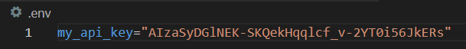

* Create a .env file and define a variable named my_api_key.
* Assign the copied Google API key to this variable.
* Paste the API key obtained from the previous steps here.

Milestone 3 : Interfacing With Pre-Trained Model

To interface with the pre-trained model, we'll start by creating an app.py file, which will contain both the model and Streamlit UI code.

Activity 1 : Load The Gemini Pro API

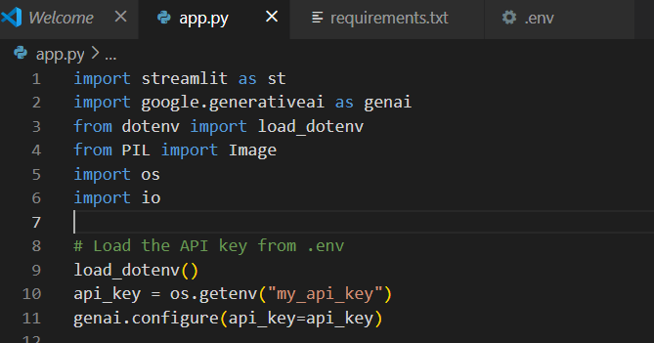

This code snippet is for initializing a nutrition app application using Streamlit, an open-source app framework, and Google Generative AI services. The script starts by loading environment variables from a .env file using the load_dotenv() function from the dotenv package. It then imports necessary libraries: streamlit for creating the web app interface, os for accessing environment variables, google.generativeai for utilizing Google's Generative AI capabilities, and PIL.Image for image processing. The genai.configure() function is called to set up the Google Generative AI API with the API key retrieved from the environment variables, ensuring secure and authorized access to the AI services.

Activity 2 : Implement A Function To Get Gemini Response

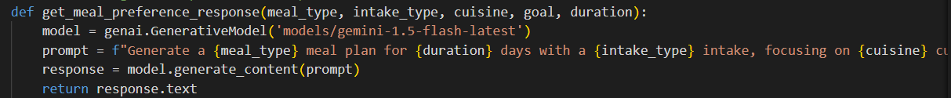

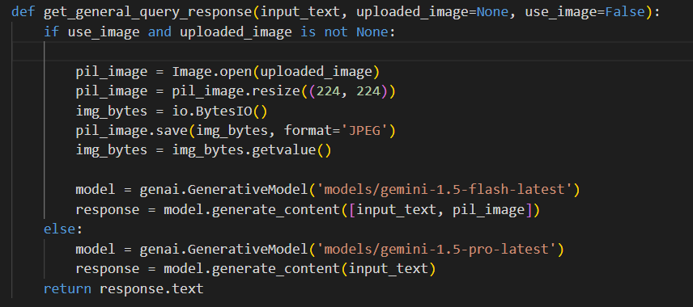

* The function get_meal_preference takes multiple input text as a parameter and sends the response accordingly
* It calls the generate_content method of the model object to generate a response.
* The generated response is returned as text.
* in get_general_query_response there are 2 models based on whether the user wants to give text or image as input criteria based on it gemini pro or gemini pro vision models are loaded

Activity 3 : Write A Prompt For Gemini Model



the variable input_prompt is a multi-line string designed as a prompt for a nutritionist AI model. It takes the input from the user for the prompt and accordingly designs the response based on image or text

Milestone 3 : Model Deployment

We deploy our model using the Streamlit framework, a powerful tool for building and sharing data applications quickly and easily. With Streamlit, we can create interactive web applications that allow users to interact with our models in real-time, providing an intuitive and seamless experience.

Activity 4 : Integrate With Web Framework

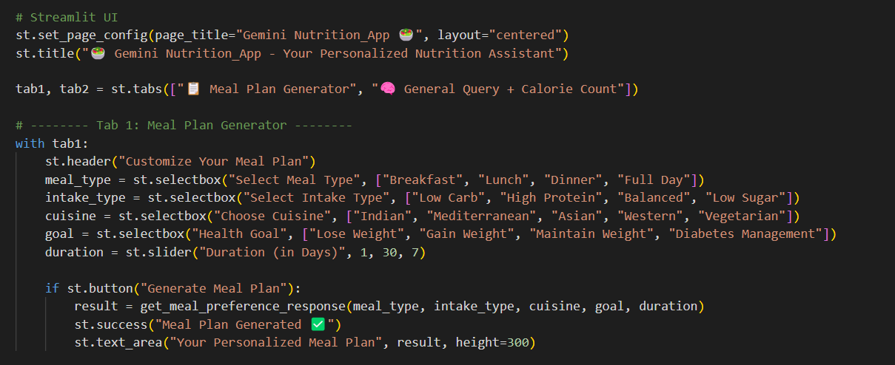

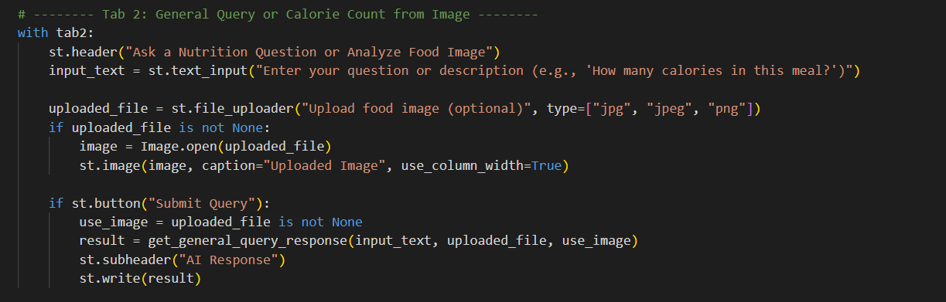

This code initializes a Streamlit application titled "AI Nutritionist App" by setting the page title and creating the app's header. It includes a text input field for users to enter a custom prompt and a file uploader for users to upload an image in JPG, JPEG, or PNG format. If an image is uploaded, it is opened using the PIL library and displayed within the app with a caption. A button labeled "Tell me the total calories" is also provided, which users can click to trigger the application's functionality for analyzing the uploaded image to calculate and display the total calorie content of the food items depicted.

Activity 2 : Host The Application

Launching the Application:

* To host the application, go to the terminal, type - streamlit run app.py

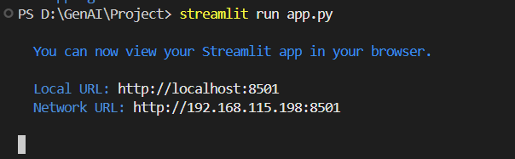

* Here app.py refers to a python script on running streamlit the below page is shown where the user is given 2 option to create his own meal plan or to see the calorie count and see various general queries related to his diet

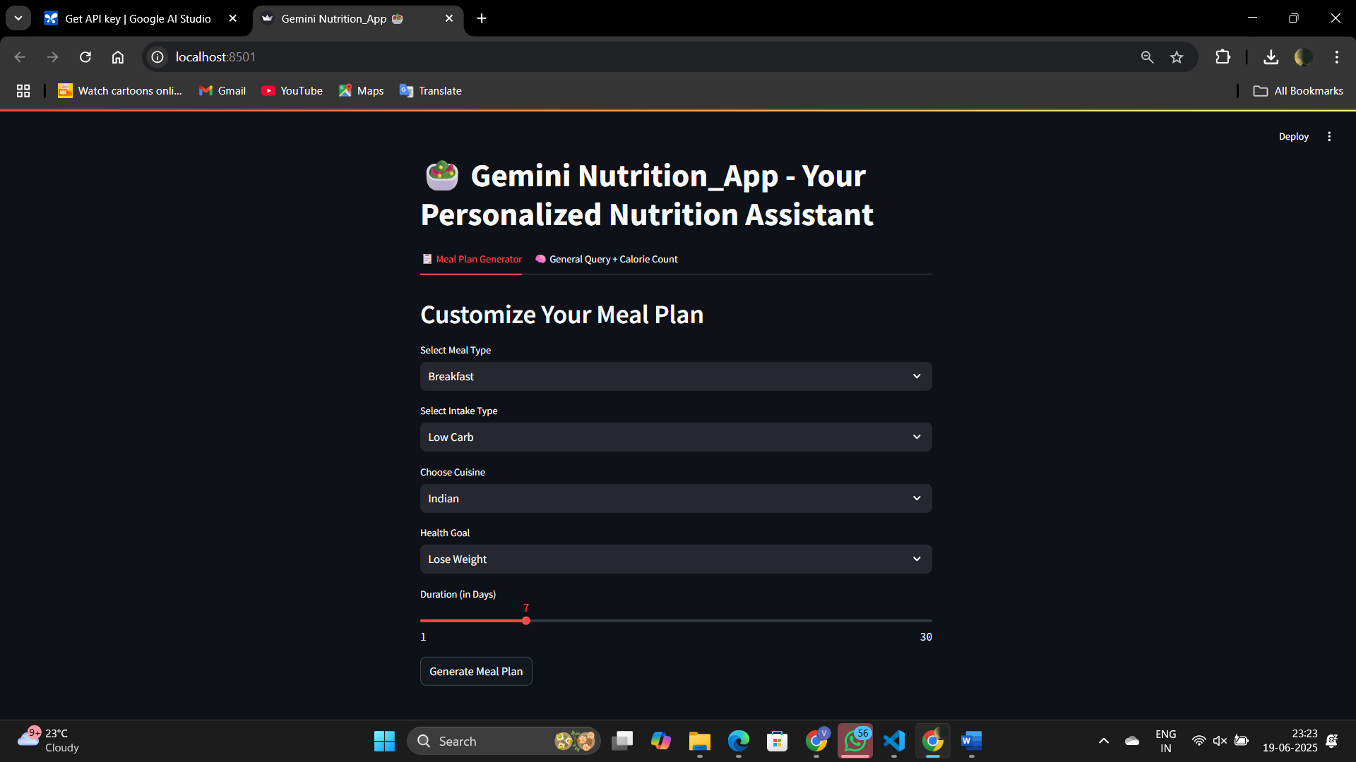

here the user has the various option as to how he wants his meal plan from breakfast,lunch,dinner to high protein,low sugar etc to various cuisine and whether he wants to gain or lose weight to how many days he wants to lose it in etc below is a sample output for a random selection.

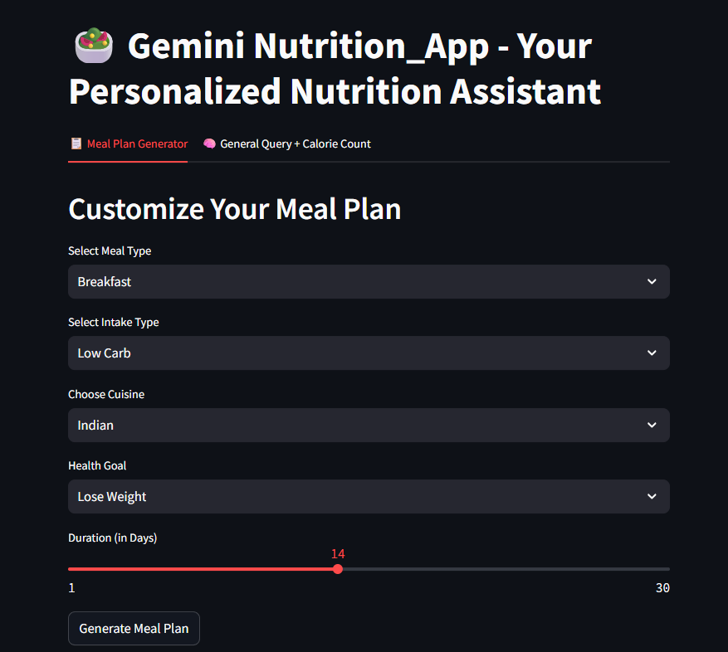

**14-Day Low-Carb Indian Breakfast Meal Plan (Weight Loss Focused)**

This meal plan emphasizes protein and healthy fats to keep you full and satisfied while minimizing carbohydrates. Remember to adjust portion sizes based on your individual calorie needs and consult with a doctor or registered dietitian before making significant dietary changes.

**Note:** "Spices" throughout refer to a blend including turmeric, cumin, coriander, chili powder (adjust to your spice tolerance), and salt.

**Day 1:**  Besan Chilla (Gram Flour Pancakes) - made with minimal water for a thicker, lower-carb version. Serve with a side of chopped tomatoes and onions.

**Day 2:** Masala Omelette - 2 eggs scrambled with finely chopped onions, tomatoes, and spices.

**Day 3:** Paneer Bhurji (Scrambled Paneer) - Crumble paneer and sauté with onions, tomatoes, and spices.

**Day 4:** Moong Dal Cheela (Lentil Pancakes) - Made with moong dal (split yellow lentils), finely grated vegetables like carrots and zucchini, and spices.

**Day 5:** Spiced Coconut Yogurt with Chia Seeds – Plain Greek yogurt (check carb content) mixed with shredded coconut, chia seeds, and a dash of spices.

**Day 6:** Vegetable and Egg Curry (minimal gravy) – Sauté diced vegetables (cauliflower, spinach, mushrooms) with eggs and spices. Keep the gravy minimal to reduce carbs.

**Day 7:** Keto Paratha (using almond flour or cauliflower) – Although parathas are typically high-carb, you can find low-carb versions online using alternative flours. Pair with a side of plain yogurt.

**Day 8:** Besan Chilla (variation) – Add finely chopped vegetables like spinach or bell peppers to your besan chilla.

**Day 9:** Masala Omelette (variation) – Add chopped spinach or mushrooms to your omelette for extra nutrients.

**Day 10:** Paneer Bhurji (variation) – Add finely chopped green chilies and cilantro for a fresh twist.

**Day 11:** Spiced Coconut Yogurt with Almonds and Flax Seeds – Replace chia seeds with almonds and flax seeds for variation in texture and nutrients.

**Day 12:** Moong Dal Cheela (variation) – Experiment with different finely grated vegetables like bottle gourd or radish.

**Day 13:** Vegetable and Egg Curry (variation) – Use a different combination of vegetables, such as broccoli and peas (limit peas due to carb content).

**Day 14:** Keto Paratha (variation) – Experiment with different fillings like paneer or finely chopped vegetables within the low-carb paratha.

**Important Considerations:**

**Portion Control:** Even low-carb foods can contribute to weight gain if eaten in excess.

**Hydration:** Drink plenty of water throughout the day.

**Variety:** While this is a 14-day plan, try to incorporate other low-carb Indian breakfast options as you see fit.

**Hidden Carbs:** Be mindful of added sugars in any sauces or condiments.

**Individual Needs:** This is a general guideline. Adjust based on your individual dietary needs and preferences. Consult a healthcare professional for personalized advice.

This plan offers a starting point. You can easily customize it based on your preferences and the availability of ingredients. Remember to focus on whole, unprocessed foods and listen to your body's hunger cues. Good luck with your weight loss journey!

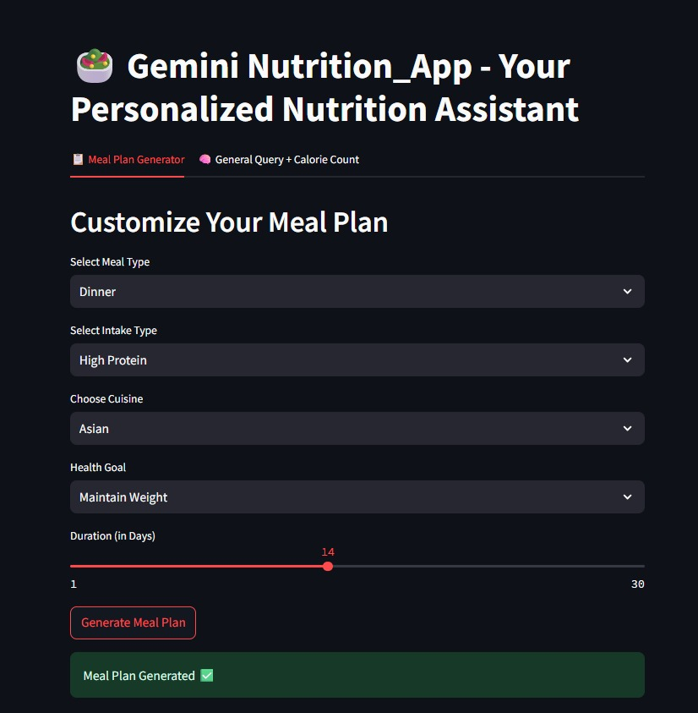

**14-Day High-Protein Asian-Inspired Meal Plan (Weight Maintenance)**

This meal plan focuses on Asian cuisine, prioritizing high-protein sources for weight maintenance. Calorie counts are estimates and will vary based on specific ingredients and portion sizes. Adjust portion sizes to meet your individual caloric needs. Remember to drink plenty of water throughout the day.

**Day 1:**

**Breakfast:** Tofu Scramble with Shiitake Mushrooms & Spinach (300 calories, 25g protein)

**Lunch:** Chicken and Vegetable Stir-fry with Brown Rice (450 calories, 40g protein)

**Dinner:** Miso Glazed Salmon with Bok Choy and Edamame (500 calories, 45g protein)

**Day 2:**

**Breakfast:** Overnight Oats with Chia Seeds, Berries, and Protein Powder (350 calories, 30g protein)

**Lunch:** Shrimp and Avocado Salad with Sesame Ginger Dressing (400 calories, 35g protein)

**Dinner:** Korean Beef Bulgogi with Shirataki Noodles (450 calories, 50g protein)

**Day 3:**

**Breakfast:** High-Protein Yogurt with Almonds and Mango (250 calories, 20g protein)

**Lunch:** Leftover Korean Beef Bulgogi with Brown Rice (450 calories, 50g protein)

**Dinner:** Chicken Satay with Peanut Sauce and Steamed Broccoli (500 calories, 40g protein)

**Day 4:**

**Breakfast**: Scrambled Eggs with Smoked Salmon and Whole-Wheat Toast (350 calories, 30g protein)

**Lunch:** Tuna Salad Lettuce Wraps (300 calories, 35g protein)

**Dinner:** Vietnamese Lemongrass Pork with Stir-fried Vegetables and Quinoa (550 calories, 55g protein)

**Day 5:**

**Breakfast:** Protein Smoothie with Spinach, Banana, and Protein Powder (300 calories, 35g protein)

**Lunch:** Leftover Vietnamese Lemongrass Pork with Quinoa (550 calories, 55g protein)

**Dinner:** Spicy Sichuan Tofu with Brown Rice and Green Beans (480 calories, 40g protein)

**Day 6:**

**Breakfast:** Tofu and Vegetable Omelet (320 calories, 25g protein)

**Lunch:** Chicken and Cashew Stir-fry with Brown Rice (450 calories, 40g protein)

**Dinner:** Pan-seared Cod with Ginger-Soy Glaze and Asparagus (500 calories, 45g protein)

**Day 7:**

**Breakfast:** High-Protein Pancakes with Berries and Greek Yogurt (400 calories, 30g protein)

**Lunch:** Leftover Pan-seared Cod with Brown Rice (450 calories, 45g protein)

**Dinner:**  Japanese Curry with Chicken and Vegetables (550 calories, 50g protein)

**Day 8-14:**  Repeat your favorite meals from days 1-7, varying them slightly to avoid monotony. Consider adding the following options:

**Protein Sources:** Shrimp, chicken breast, lean pork, tofu, tempeh, edamame, lentils, chickpeas, fish (salmon, cod, tuna).

**Vegetables:** Broccoli, spinach, bok choy, asparagus, green beans, carrots, bell peppers, mushrooms, onions, zucchini.

**Grains (in moderation):** Brown rice, quinoa, whole-wheat noodles, shirataki noodles.

**Healthy Fats (in moderation):** Avocado, nuts, seeds, olive oil.

**Important Considerations:**

**Portion Control:** Pay attention to your serving sizes to maintain your weight.

**Spice it Up:** Asian cuisine offers a wide range of spices and flavors. Experiment with different sauces and seasonings to keep your meals interesting.

**Hydration:** Drink plenty of water throughout the day.

**Listen to Your Body:** Adjust the meal plan based on your hunger and energy levels.

**Consult a professional:** If you have any specific dietary restrictions or health concerns, consult a registered dietitian or healthcare professional before making significant changes to your diet.

This is a sample meal plan. Feel free to adapt it to your preferences and dietary needs. Enjoy your delicious and healthy Asian-inspired meals!

On using general query button and uploading image to count calories:

